Livingston Avenue School
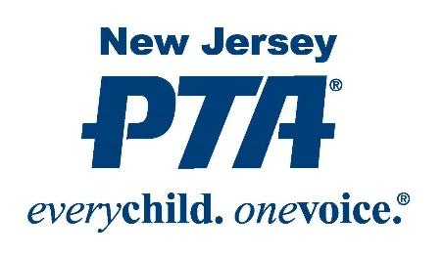
The PTA is the oldest and largest child advocacy association in America. Today’s PTA is comprised of nearly 5 million parents, teachers, grandparents, caregivers, foster parents and other caring adults who share a commitment to improving the education, health, and safety of all children. We speak with one voice for every child.
Today, the issues that affect our children extend beyond the walls of LAS. The PTA’s nationwide network provides the forum and tools to collectively influence the decisions that affect children throughout their districts, within their states and across the nation. This mission is unique to the PTA.
Here at LAS, the PTA funds many of the enjoyable activities and educational programs our children look forward to each year. Please join and let’s work together to reach our goal of 100% membership.
Your $10.00 membership fee, per parent, enables us to jump-start funding so we can continue to assist our children’s school with providing programs and improvements that help make LAS so special.
Parents can become a member of the PTA by sending in the form below to LAS or join online.
To join online go to www.pt-avenue.com/join/ and follow the prompts. Note the PTA/PTSA name for our school is ‘Livingston Avenue School Cranford PTA’. (There is a second Livingston School in New Jersey so do not select this school in error.) Payment is made with a credit card.
Thank You,
Amy Kowalski - PTA Membership Chairperson

Livingston Avenue School PTA Membership Form
#1______________________________________________ $ 10.00 Member #2______________________________________________ $ 10.00 Member
$1 donation is appreciated for refreshments throughout the year. Total $_____________
Child Name ____________________________________________ Class____________
Child Name ____________________________________________ Class____________
E-mail Address ___________________________________________________________
Please return form and payment in an envelope marked ‘Attn: Amy Kowalski’ by Sept 22nd. It can be returned to your child’s teacher or dropped off at the office in the designated box. Checks payable to LAS PTA.

